PHASE 5 – Email Notification & Activation
Activity : 7 Email Action Setup.
- After classification, an email notification is sent using Flow Designer.
- Set Action Send Email.
- To : Caller → Email.
- Subject : Your Request for the issue has been submitted.
- Body : Ticket confirmation message.
- Then Click the Done button.
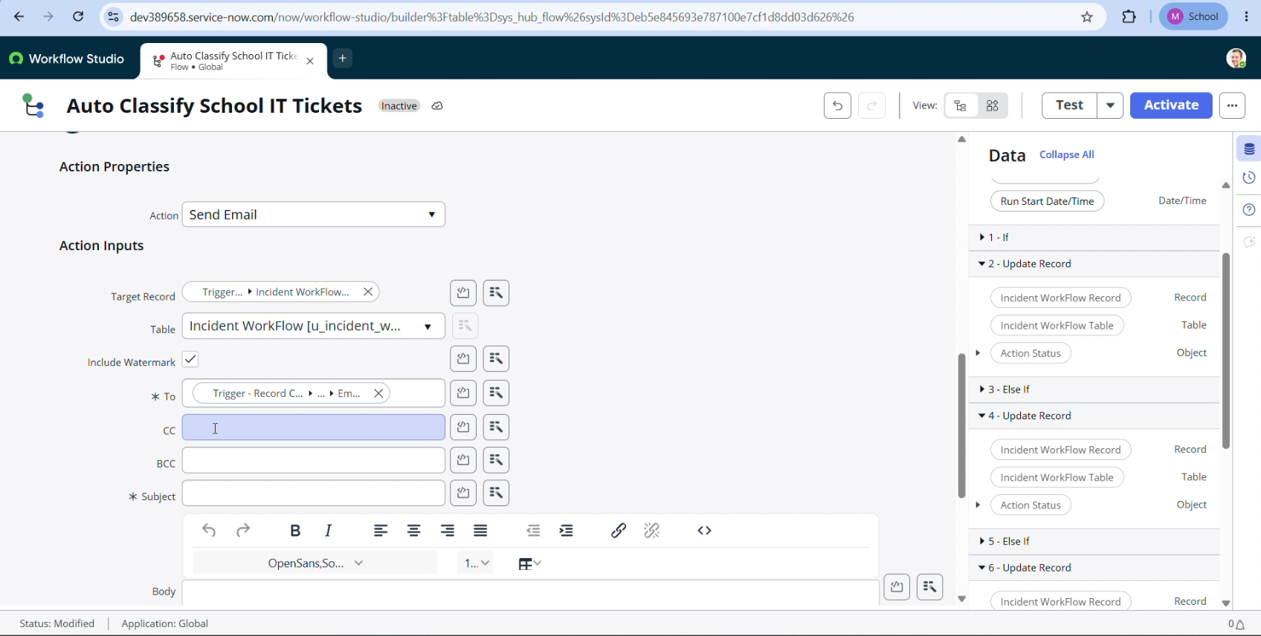
- Now Click the Activate button from the top right corner.

